SECOND TERM EXAMINATION

CLASS: JSS 2
READ AND FOLLOW THE INSTRUCTIONS CAREFULLY.
Objectives (Answer ALL Questions)
- An algorithm that performs its task quickly and uses minimal resources can be said to be? (a) reliable (b) scalable (c) efficient (d) adaptable
- An adaptable algorithm (a) is cheap and easy to purchase (b) is the trigger for the program (c) can be applied to a range of related problems with minimal adjustments (d) none of the above
- What can we do to show innovation and creativity? (a) talk to your teacher to give you ideas(b) code what others have done (c) embrace mistakes as opportunities to learn and improve (d) embrace prayers and fasting
- As a coder, you must ensure that every line of code is perfect immediately after you code it. (a) True (b) False (c) None of the above
- It is advantageous for coders to collaborate and share ideas with others (a) True (b) False
- An algorithm must be able to produce at least one output (a) True (b) False
- _______ is the ability to imagine or perceive things that are not yet real or in existence. (a) Coder (b) Imagination (c) Programming (d) Letter.
- One of the importance of a backdrop to a project is _________ (a) to give more meaning to the program (b) to make it durable (c) to make it movable (d) none of the above
- Costume relates to the appearance of a ______. (a) Code (b) Sprite (c) Background (d) Image
- One of the main purposes of the algorithm is to make the program flow ______? (a) easy (b) good (c) subtle (d) none of the above
- Which of the following is a backdrop found in scratch? (a) cat (b) background (c) castle 1 (d) backdoor
- When an algorithm is easy to understand and comprehend, we say that such an algorithm has the quality of (a) efficiency (b) scalability (c) clarity (d) adaptability
- Which of the following does not represent being imaginative and creative? (a) thinking beyond the obvious solutions (b) experimenting with new ideas (c) making sure you code for long hours(d) finding unique ways to solve problems

- When we click the button, which of the following have we done? (a) sent a message to

the owner of the program (b) we have started a challenge (c) we have started executing some instructions (d) none of the above
- Event blocks are popularly known as (a) yellow blocks (b) trigger blocks (c) green flag blocks (d) run blocks
- An imaginative and creative coder is not afraid to experiment with the following expect (a) tools (b) ideas (c) safety (d) techniques
- The code block 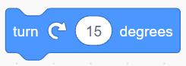 can be used for which of the following purposes (a) defining functions (b) handling directions (c) sensing (d) changing appearance
- Depending on the ______ a sprite is pointing in, the “Move () Steps” block will move the sprite differently (a) rotation (b) direction (c) trigger (d) appearance
- The duration in which all things happen, or a precise instant that something happens can be referred to as (a) rotation (b) time (c) direction (d) control
- ______ are used to represent the current position on the stage (a) motion block (b) coordinate (c) event block (d) sensing block
- The maximum number for the positive Y axis is (a)180 (b) 240 (c) 360 (d) 480
- The variable block used to hide specified variables from the stage or the main screen is called the ___ block. (a) change () by () (b) set () by () (c) hide variable () (d) show () by ()
- At the center of the stage the X and Y coordinates of a sprite are usually (a) (-1,0) (b) (0,0) (c) (12, 40) (d) none of the above
- ______ means to turn around a center point. (a) Degree (b) Rotation (c) Position (d) Direction.
- This code block would turn the sprite towards what direction? (a) Counterclockwise (b) Clockwise (c) Striaghtwise (d) none of the above.
- There are _____ types of rotation in scratch. (a) 3 (b) 2 (c) 4 (d) none of the above.
- ______ is information that the program receives. (a) Input (b) code blocks (c) info (d) all of the above
- _______ involves thinking beyond the obvious solutions? (a) innovation and planning (b) Plan and Pseudo code (c) innovation and creativity (d) Break down the problem.
- _____ is one of the simple steps to encourage innovation and creativity? (a) Thinking beyond the problem (b) Pseudo code (c) Solution (d) all of the above.
- Scratch determines where to display sprites through the (a) code block (b) coordinate system (c) trigger (d) none of the above
Theory
INSTRCUTION: ANSWER ANY 4 QUESTIONS
- List Five (5) qualities of a good algorithm.
- Define the term Imagination.
- What is a backdrop?
- List the properties of an Algorithm.
- Observe the below program and write a sample algorithm for it.
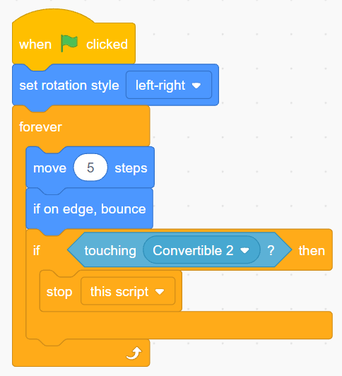
- Define the term “Rotation”.
- List any example uses of the “Direction” block.

